***Galactic crystal ball***

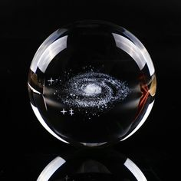

*The galaxy crystal ball is made of K9 crystal material and modern 3D laser engraving technology.(See detailed description below to understand the features and differences of the 3 soles.) You can write in the note the type of sole you choose when ordering. We will contact you before shipping.*